**PRESS RELEASE**

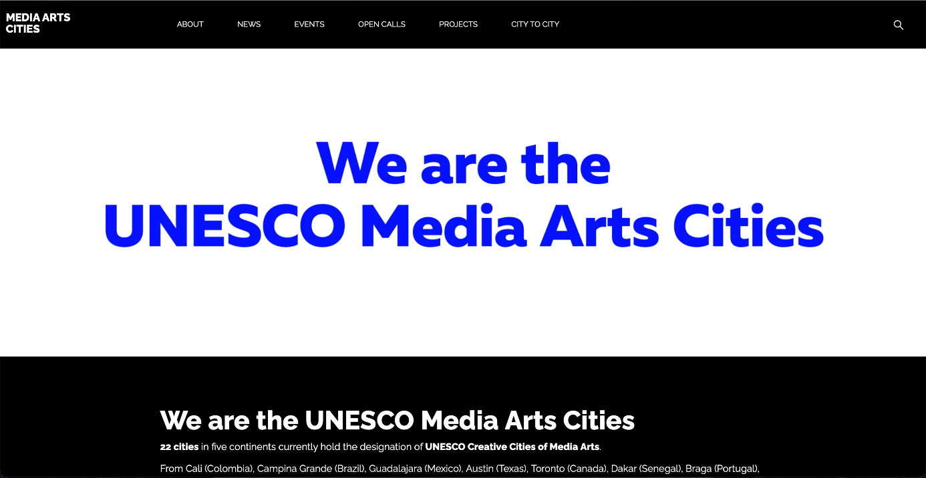

The 22 Cities of Media Arts of the UNESCO Creative Cities Network are pleased to announce the launch of their website.

<https://mediaartscities.com/>

Intended for the general public as well as digital artists, digital creation professionals, and the city representatives, this site provides valuable information on the news of these cities and on the joint projects they are carrying out in support of digital creation.

Thanks to the different sections (About, News, Events, Open Calls, Projects, City to City), keep up to date with the activities that the 22 cities are carrying out locally and internationally and participate in some of them.

A section specially devoted to the *City to City* online collaborative project emphasizes the joint effort of the cluster cities to rethink the methods of support of digital artists by offering them the opportunity to collaborate during online residencies and to see their works then broadcasted online as well as in cities’ flagship festivals.

**UNESCO Creative Cities for Media Arts**

A UNESCO Creative City for Media Arts is a city that has joined [the UNESCO Creative Cities Network](https://en.unesco.org/creative-cities/home" \o "Creative Cities Network) (UCCN) as notable in the field of media arts.

Currently, 22 cities from 21 countries located on four continents with a combined population of over 24 million bear the title of UNESCO Creative City for Media Arts : Austin (USA), Braga (Portugal), Cali (Colombia), Campina Grande (Brazil), Changsha (China), Dakar (Senegal), Enghien-les-Bains (France), Guadalajara (Mexico), Gwangju (Republic of South Korea), Hamar (Norway), Karlsruhe (Germany), Kosice (Slovakia), Linz (Austria), Lyon (France), Modena (Italy), Namur (Belgium), Sapporo (Japan), Tbilisi (Georgia), Tel-Aviv (Israel), Toronto (Canada), Viborg (Denmark) and York (United Kingdom).

All these cities work together towards a common goal: to place media arts and cultural industries at the heart of their development plan at the local level and actively cooperate at the international level.

Designated UNESCO Creative Cities for Media arts support:

* the development of cultural and creative industries triggered and facilitated by digital technologies;
* the successful media arts integration leading to the improvement of urban, sustainable, and resilient lives;
* the growth of media arts forms seeking the participation and inclusion of civil society;
* wider access to culture and information through digital technology development and ​digital technology education programs;  ​
* residency programs,​ local as well as international collaborations in media arts, and the creative sphere.

**UNESCO Creative Cities Network**

Launched in 2004, the UCCN is aimed at promoting cooperation with and among cities that have identified creativity as a strategic factor for sustainable urban development as regards economic, social, cultural and environmental aspects.

It is currently made up of 295 cities from more than 80 countries and covers 7 creative fields: Crafts & Folk Art, Design, Film, Gastronomy, Literature, Music, and Media Arts.

The UCCN is a privileged partner of UNESCO, not only as a platform for reflection on the role of creativity as a lever for sustainable development but also as a breeding ground of action and innovation, notably for the implementation of the 2030 Agenda for Sustainable Development.

By joining the Network, cities acknowledge their commitment to sharing best practices, developing partnerships that promote creativity and the cultural industries, strengthening participation in cultural life and integrating culture in urban development plans.